Upper Dash
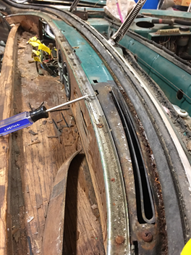 | (1) wooden dash is secured by chrome strip and roughly 10 screws | 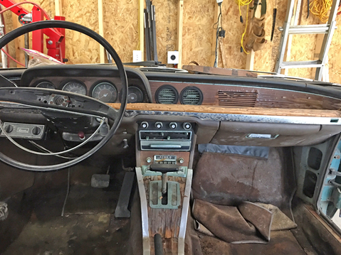
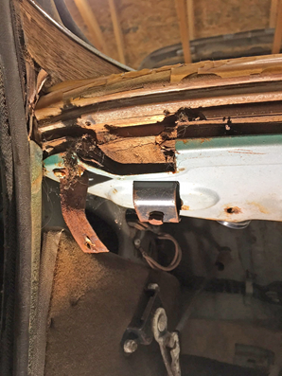 | (2) wooden dash  Secured by bolt with u-brace from underneath | 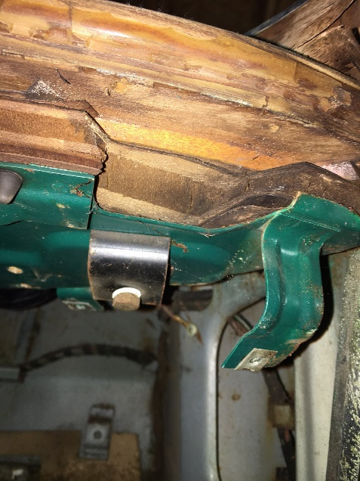
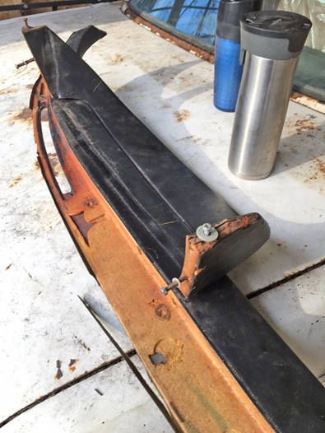 |  | Dash pad with instrument cluster shroud is secured by two threaded pegs with 10mm nuts (oriented forward) and two screws from below up into dash.  Dash pad has embedded clips that imbed into sheet metal base.

